top 10 things to love about bronson
Superintendent Rick Hilderley

Recently, a colleague (who is a veteran school leader) asked me what things surprised me in my first year as Superintendent. We had a nice discussion about some of the things I have learned and in some cases, still have learning to do. As I reflected on the conversation later it occurred to me how positive the entire experience has been. Difficult things have hap- pened, but my default response to those who ask is to talk about the posi- tive. That is because there is SO much to talk about! Therefore, because I introduced myself in the first Viking Voice with a list of ten things, I decided to do the same for the “wrap-up.” Here are ten things to LOVE about Bronson:

10 - support
I have attended many events in the past months. Sports, music and drama,
fund raisers, benefits and more. Every place we go we find a bigger than expected crowd of people supporting the event. For a town this size, the numbers that turn up for events is remarkable. We feel so fortunate to now live in a place with the kind of spirit that exists here. Thank you Bronson, for a fantastic year of surprises. We look forward to the years ahead!

9 - my staff
The people who work with me daily at the Chicago St. office have had to
spend the last several months breaking in a rookie. They have been patient, supportive, and helpful. Their hard work and steadfast devotion to doing things right has made my transition to Bronson more easy than I thought possible.

8 -board members
I am sure that it looks like pandering to spend a few lines snuggling up to
my bosses, but I do want people to know how much these people care about Bronson! They put the needs of kids first, and they do so in respon- sible ways. It has been a joy to work with this group!

7 -food
Because I am like most men and driven by my stomach, I had favorite
places to eat in my life before Bronson. Happily, we have discovered new great places and developed favorites all over again!
“Continued Page 2”

top 10... continued
alumni dinner

6 - the pace
The further you go down U.S. 12 toward Detroit or Chicago, the greater the
“pace of life” picks up. I am not one who likes to hurry or rush; too much anxiety! I also don’t enjoy dawdling or getting stuck in the mud. Coming to a place in the middle of the state has also brought us to a pace that is “in the middle;” not to slow or fast – just right.

5 -friends
One of the risks that my wife Amy and I took was leaving a place we had
been our whole lives and the friendships we had in place. Bronson has provided us with more than we ever imaged in terms of friendship. Connect- ing with a whole new group of people has been a pleasant and rewarding surprise for both of us.

4 -farm life
When I was very young, we lived on a farm and for years after I visited cous-
ins in the summer to stay on the farm. Watching the crops mature, the har- vest, spring planting, getting an unintended car wash from an irrigation pivot; for me it provides a calming sense of purpose, routine, and structure. I don’t always love getting stuck behind a rig on Parham Rd when I’m in a hurry, but I will take that over city traffic any day!

3 - the staff
And it isn’t just me who feels this way! Students tell me that the teachers
here want them to do well and that they go out of their way to help. That kind of dedication is what makes for a successful district.

2 -the people
This was easily the first thing that comes to mind. The parents and other
people of this community are kind, generous, friendly, and very proud of their town (as they should be). It has been a pleasure to join that sense of Viking Pride!

and the number 1 reason
the students
For me, the students lead this list. Our kids work hard, smile, help others,
greet you politely, and have a wonderful spirit. I enjoy my visits to classrooms probably more than any other single activity.

Welcome all BHS students, teachers and staff, both past and present! The Annual BHS Alumni dinner and program will be held on Saturday, June 17, 2018, at the Chicago Street School gym. Social hour begins at 4:00 PM with potluck dinner and program at 6:00 PM. Honored classes are 1948, 1958, 1968 and 1993.

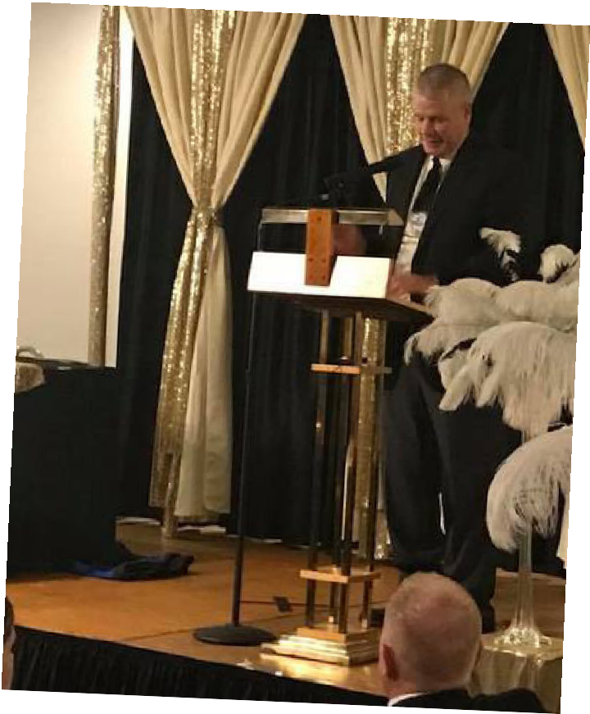

award winning may term gives bronson students advantages
The Bronson Junior/Senior High School has a unique May term, which is a 30- day term featuring academic electives along with a credit recovery program. The Bronson High School runs two terms similar to semesters and an addi- tional five-week May Term. During May Term, the district’s academically ac- celerating students can take a variety of academic electives, such as organic chemistry. For the students who need additional instruction in order to master their standards based core classes, May Term offers five weeks of additional small group/individualized instruction to assist them in recovering their credits and showing mastery of the standards. May Term offers numerous elective options, including forensic science, interior design, origami, robotics, Civil War history, the art of cakes, introduction to engineering, archery, strength training, creative writing, geocache, the Holocaust and literature, ceramics, anatomy, dance, short stories and first aid.
May Term has made a huge difference for many of the district’s students. Currently there are students participating in 120 credit recovery opportunities. We have already had 20 students recover credit, and are hopeful all students will recover some credit this May term. In other words, May Term, on average, helps 41% of Bronson Schools’ students meet their graduation requirements.
Bronson’s May Term has been recognized by Michigan Association of School Administrators as part of their Winners’ Circle Awards for effective programs or practices that achieve results and can be replicated in other districts.

congratulations mr. hicks!
An Honor Well Deserved.
We were proud to learn this year’s Educator of the Year honoree by the Coldwater Area Chamber of Commerce is our own Mr. Hicks!

A former student said, ”if you know this man, you
are better for it.”

May 21
Spring Choir Concert 7 p.m.

May 22
Senior Breakfast Commencement Rehearsal Anderson Elementry Field Day

May 23
Senior Recognition Night

May 24
Commencement 7 p.m.

May 25
Kindergarten Graduation 3rd Grade Field Trip

May 28
Memorial Day – No School

May 29
Ryan Elementary Field Day

May 30
Kindergarten Field Trip
Ryan Elementary Awards 2 p.m.

May 31
5th Grade Field Trip

June 1
Half Day – Last Day of School

Have a Great Viking Summer!

Check our Facebook page Bronson Rocks! or www.BronsonSchools.org for weekly calendars!

how to keep your kids brains active during school breaks
Summer vacations are a wonderful time to relax and enjoy a break from the routine of school. But, it is important to keep kids engaged in learning activities to keep their minds active. Here are a few suggestions to follow to help ensure your child’s brain stays engaged without ruining the fun of hav- ing time off from the routine of school.

limit electronics
If you let them, kids will happily stay glued to their screens all day long. To keep your child’s mind engaged, you have to limit his or her screen time. Kids need to be physically active, they need to run around, and engage in sports to stay healthy. Active kids tend to perform better academically and are able to focus for longer periods of time than kids who are not active. The key challenge for parents today is to find things for their children to do that they will find more interesting than electronics.

visit places
Our brain continues to develop all the way into our twenties. That means children’s brains are primed to grow while being exposed to new experiences that teach them new things. One of the best ways to stimulate curiosity and keep young brains active is to expose them to as many new things as possible. Take your child to places you have not visited before or do an activity you have never done before. Take time to find out what’s going on in your community. Museums, city recreation depart- ments, parks and libraries are continually putting on special events. Find places or events where your child can engage in hands-on activities. Pretend to be a tourist in your own town. If you dig a bit,
you’ll find a ton of interesting places, just a few miles from your home, that you have never taken time to explore. After your outing, ask your child to discuss their experience as well as to write a story with a drawing about something new they learned that day.

solve problems
If you want to keep your child’s brain active, provide them with puzzles or challenges to solve. Puzzles force children to tap into their problem solving and creativity skills. The more kids engage in activities that stimulate these problem-solving and creative parts of their brains, the better they will become at dealing with and overcoming challenges encountered in school and personal life.
Here are a few types of activities that are guaranteed to stimulate children’s brains:
- Completing age appropriate jigsaw puzzles
- Solving Rubik’s Cube puzzles
- Answering Riddles and Brainteasers
- Putting together LEGO sets without looking at the instructions

read books
Few things stimulate the mind as much as reading a good book. Let your children pick out something they want to read. All types of reading will help to develop critical thinking and problem-solving skills. Even comic books can help a child stay mentally active. Allowing children the ability to read the type of books that they want to read will mean more time reading, and lead to better school performance. Our local libraries promote summer reading programs to entice children to stay actively engaged in learning activities during vacation time. To make it even more interesting, children can earn exciting prizes for spending time reading books they like.
In closing, the more fun the activity, the more likely your child will eagerly participate and want to repeat the experience.
SchoolScout.com

